Construction Traffic Management Plan

**GENERAL NOTES**

**PROJECT REF: Land Adjacent to No 29. Chalkshire Rd, Butler's Cross, Aylesbury HP17 0TS PLANNING REFERENCE: 22/07562/FUL**

**PLANNING CONDITION: 13**

|  |  |  |  |
| --- | --- | --- | --- |
| **Author** | Kelvin Clarke | **Reviewer** | Jamie Newell |
| Date: | 29.7.25 | Date: | 30/7/25 |

|  |  |  |  |  |
| --- | --- | --- | --- | --- |
| **Revision** | **Date** | **Status** | **Prepared by** | **Approved by** |
| 2.0 | 11.08.2025 | Draft | KC |  |

# INTRODUCTION

## Preface

This Construction Traffic Management Plan (CTMP) has been prepared in response to a pre-commencement condition for planning reference 22/07562/FUL

Condition no. 13 states the following:

Prior to the commencement of any works on the site, a Construction Traffic Management Plan detailing the management of construction traffic (including vehicle types, frequency of visits, expected daily time frames, use of a banksman, on-site loading/unloading arrangements and parking of site operative’s vehicles)

## Objectives

The overall objective of this CTMP is:

* Ensure public and worker safety.
* Minimize impact on surrounding traffic and pedestrians.
* Maintain emergency access.
* Comply with local authority and regulatory requirements.

# SITE INFORMATION

### Description of site:

The site is currently an open field providing grazing land for horses part of the equestrian establishment at Home Close Farm.

**Surrounding Area:**

# The application site is located in Butlers Cross, towards the southern end of Chalkshire Road, on its west side, to the north of a ribbon of residential development. It has a road frontage of 42.8 metres, bounded by a mixed hawthorn and leylandii hedge, and is just under 48 metres in depth. To the south of the site is a public footpath which forms part of the “Aylesbury Ring” circular route

**Description of works*:***

# Erection of three pairs of Semi-Detached Dwellings over two storeys with associated external hard/soft landscaping works.

#### Site Location

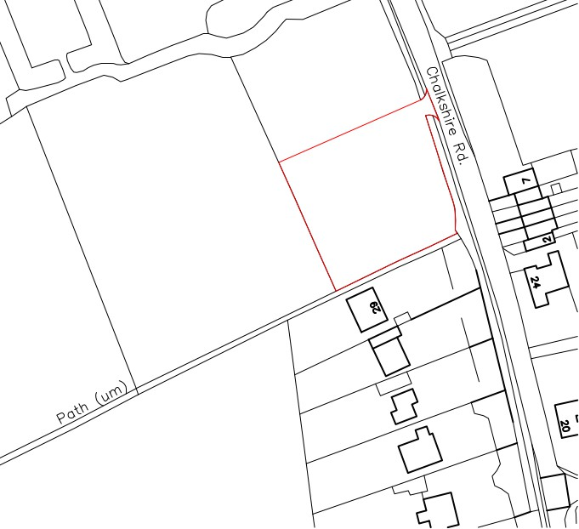

## CONSTRUCTION DETAILS

## Works Programme

The current estimated programme of works is such that works are expected to commence in October 2025 with the works anticipated to be completed in July 2026.

## Construction Access Route

## Site Access

Consideration has been given to the approach and departure routes from the site in order to minimise the impact on all major cycle routes, schools, weight restrictions, low bridges and narrow roads.

The approach and departure routes will be confirmed to all subcontractors and delivery companies at Pre-tender, on all orders and pre-start meetings. The site manager and banksman will be responsible for enforcing the use of the approach and departure routes.

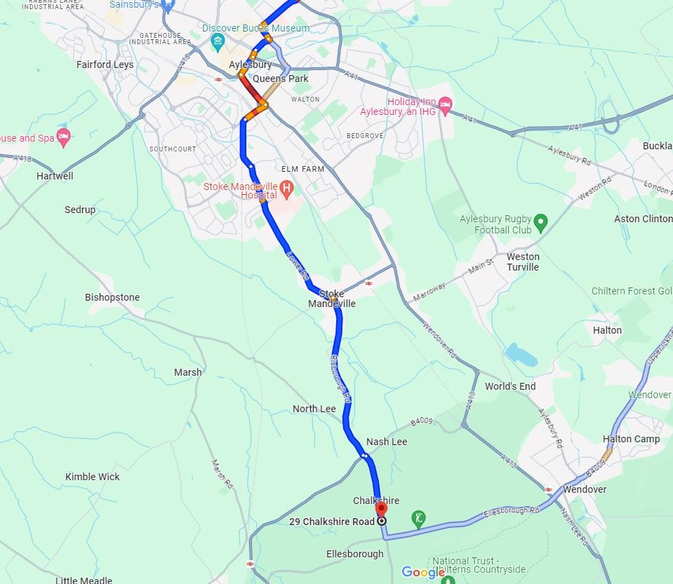 **Construction Traffic Route**

**Approach Route To/From Alyesbury**

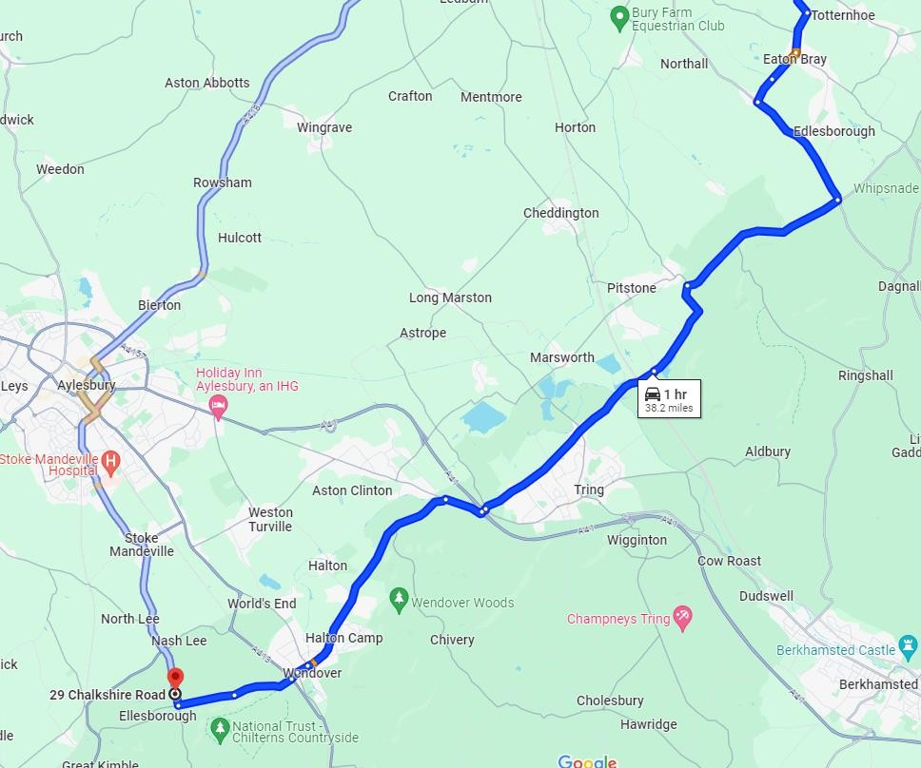

# Departure Route To/From M1

## Loading / Unloading, Turning and Parking

Heavy Goods Vehicle deliveries will load and offload from within the designated construction compound. The location of this compound and the route to/from it is indicatively shown in the site setup plan. This will be controlled by a supervisor and its operation will be tightly controlled and job specific method statements will be prepared and distributed to the operatives.

All goods vehicle manoeuvring will take place within the construction compound with vehicle manoeuvring being controlled by a banksman. The compound layout will ensure that vehicles can exit and enter in forward gear. All construction routes to and from the construction compound will be designed to allow safe goods vehicle manoeuvring.

The construction compound will also cater for site offices, welfare facilities and other similar facilities.

A car parking area comprising up to 10 spaces will be provided as necessary to suit construction activities undertaken at the time.

## Site Working Hours

All ‘noisy activities’ will be carried out within the following ‘restricted hours’:

08:00 to 18:00 Mondays to Fridays; and

08:00 to 13:00 during Saturdays; and

At no other times, including Sundays or Public Holidays.

No work will be undertaken on Sundays or Public Holidays.

## Construction Materials

A range of construction materials will be required on-site throughout the construction period. These materials include but are not limited to:

Bulk aggregates for fill, pavements and backfill

Cement and associated materials

Ready mixed concrete

Structural timber

Bricks, blocks, sets, kerbs and paviours

Roof tiles

Cement/Sand for floor screed

Insulation materials

Doors, windows and internal fixings

Bituminous materials for roads and pavements

Drainage pipework and ductwork internal materials

In addition, buildings sundries, temporary structures within the site compound for site accommodation and storage, plant and equipment used within the construction process and the needs of the construction workforce will all be delivered to the Site.

**Site Layout Plan**

**ESTIMATE OF DELIVERY VEHICLE**

**MOVEMENTS FOR CONSTRUCTION**

## Introduction

This section provides an estimate of the total number of delivery vechicle movements associated with construction activities.

Week 1: 1no. Flatbed Delivering Site Welfare Units 1no. Low Loader Delivering Plan

Week 2: 8 Wheeler Tipper (8/day for 3 weeks)

Week 4: 8m3 Concrete Wagon During foundation works (4/day for 1 week) General: 18T Flatbed (2/week)

Crane (1 Day/ 3no visits throughout).

Vehicle Types

8-Wheeler: Capacity: 16 tonnes or 13 cubic meters.

Length: Approximately 9.1 meters.

Width: Around 3.2 meters.

Height**:** Roughly 3.7 meters.

Flatbed: Capacity:5.5T

Length: 3.45 meter

Height 3.45 meters

8M3 Concrete Wagon:Length: 9.15 meters (30 feet)

Width: 2.55 meters (excluding mirrors)

Height: 3.75 metersWeight (fully loaded)

 Approximately 32 tonne

### Management and control of construction logistics

Parrott Construction will ensure that all contractors and subcontractors undertake the works in accordance with the approved routings, plans and measures presented in this CTMP. Where necessary, they will identify and address any requirements to achieve this; this will include, but is not limited to, the following:

Identification of approved routes to all contractors and subcontractor construction vehicles and implement a monitoring regime to ensure compliance;

The phasing and timing of deliveries to ensure that previously identified working hours and any subsequently agreed restrictions on delivery times are maintained to avoid unnecessary congestion.

Implement restrictions on both on and off-site parking space within the construction site and within the vicinity of the site on the public highway.

Provision of a timely efficient delivery system to avoid the stockpile of waste materials on site.

# STRATEGIES TO REDUCE IMPACTS

## Safety and Environmental Standards and Programmes

The Contractor will be committed to ensuring all contractor and sub-contractor vehicles arriving at site comply with sufficient safety measures and requirements.

Industry best practice will be adopted wherever possible to support the construction phase of the proposed development. This will be achieved by ensuring that, through the procurement process, the main and sub-contractors employed will be members of or signed up to relevant best practice schemes and initiatives including: -

Considerate Constructors Scheme (CCS) – promotes best practice that relates to on-site activities and those in the vicinity of the site. It is noted that this site will be registered under this scheme.

Construction Logistics and Community Safety (CLOCS) – brings the construction logistics industry together to revolutionise the management of work-related road risk and ensure a road safety culture is embedded across the industry. As above, businesses will be required to be Silver standard members of the scheme before they can deliver to the site.

HGV Direct Vision Standard – for ensuring that vehicles are adapted to maximise vision around the vehicle from the driver’s perspective to minimise risk to vulnerable road users. All suppliers and hauliers will be required to achieve a three-star rating.

## Adherence to Designated Routes

All suppliers delivering materials to the site will be instructed to do so in accordance with the vehicle routing outlined.

The restricted routes will be recorded clearly on a map and communicated to all drivers, sub-contractors, and suppliers.

## Delivery Scheduling

The overarching principle for the CTMP is to protect highway and pedestrian safety during the construction phases.

### The Site Manager will coordinate deliveries and collections to optimise the frequency of deliveries, reduce congestion and make more efficient use of delivery vehicles. The bulk of deliveries will be after 9.30 am and before 15.30 to avoid peak hours.

